

**cDOT 9.1P12 Upgrade from 9.1P7 – Single Node Backup Cluster**

**Authors:** Ian Daniel

**Contributors: Craig Goettig**, Joel Edstrom, Ken Zola, Adrian Wicks

**Document Version:** V0.2

**Date:** April 2018

Status: Draft

**CONFIDENTIAL INFORMATION**

This document contains information proprietary to Thomson Reuters and may not be reproduced, disclosed or used in whole or part without express permission of Thomson Reuters.

© Thomson Reuters 2018

Contents

1 Introduction 3

1.1 Management Summary 3

1.2 Change History 3

1.3 Distribution List 4

1.4 Glossary 4

2 Pre-Upgrade Process (9.1P12) 5

2.1 Description 5

2.2 Tasks 5

2.2.1 Obtain The Correct ONTAP Version And Make it Available Via HTTP 5

2.2.2 Check For Hardware Issues 5

2.2.3 Check DNS Servers 14

2.2.4 Check/Update DQP 14

2.2.5 Check/Update Disk Firmware 15

2.2.6 Check/Update Shelf Firmware 15

2.2.7 Reboot Service Processor 16

2.2.8 Generate An Upgrade Advisor 16

2.2.9 Check Upgrade Advisor 17

3 Upgrade Process (9.1P12) 18

3.1 Description 18

3.2 Tasks 18

3.2.1 Download Code Onto All Nodes 18

3.2.2 Check All Aggregates Are Online 18

3.2.3 Check All Aggregates Have Enough Space 18

3.2.4 Check All Volumes Are Online 18

3.2.5 Check All Volumes Have Enough Space 19

3.2.6 Check For Running Jobs 20

3.2.7 Check Number of Snapshots is Less Than 20000 Per Node 20

3.2.8 Check For Disks in Maintenance, Pending or Reconstructing State 20

3.2.9 Quiesce SnapMirror 20

3.2.10 Send ASUPs Prior To Upgrade 20

3.2.11 Disable Case Generation Prior To Upgrade For 4 Hours 20

3.2.12 Perform Upgrade 20

3.2.13 Set the image as default image 21

3.2.14 Reboot the single node backup cluster 21

4 Post-Upgrade Process (9.1P12) 22

4.1 Description 22

4.1.1 Resume SnapMirror 22

# Introduction

## Management Summary

This document details the process used to upgrade cDOT from 9.1P7 to 9.1P12. This document is strictly for backup (single node) clusters only.

## Change History

|  |  |  |  |
| --- | --- | --- | --- |
| **Ver** | **Date** | **Author** | **Key Changes** |
| 0.1 | April 2018 | Ian Daniel | Initial Version |
| 0.2 | April 2018 | Ian Daniel | Modified prechecks |
|  |  |  |  |
|  |  |  |  |
|  |  |  |  |
|  |  |  |  |
|  |  |  |  |
|  |  |  |  |
|  |  |  |  |
|  |  |  |  |
|  |  |  |  |
|  |  |  |  |
|  |  |  |  |
|  |  |  |  |
|  |  |  |  |
|  |  |  |  |

## Distribution List

|  |  |
| --- | --- |
| **Name** | **Role** |
| Storage Engineering | Reviewer |
| Storage Delivery | Reviewer |
| Storage Architecture | Reviewer |

## Glossary

|  |  |
| --- | --- |
| **Term** | **Definition** |
| cDOT | clustered Data ONTAP |
| Vserver | A logical storage virtual server, also known as a Storage Virtual Machine (SVM), which contains LIFs, Volumes, and configuration information such as access control details. |
| LIF | Logical Interface – a cDOT logical network interface with an IP address, assigned to a single Vserver. |
| CIFS | Short for Common Internet File System, a protocol that defines a standard for remote file access using millions of computers at a time. With CIFS, users with different platforms and computers can share files without having to install new software. |
| SMB | Short for Server Message Block, a message format used by DOS and Windows to share files, directories and devices. |
| NFS | A distributed file system protocol originally developed by Sun Microsystems in 1984, allowing a user on a client computer to access files over a computer network much like local storage is accessed. |

# Pre-Upgrade Process (9.1P12)

## Description

Prior to upgrading a cluster to 9.1Px you first need to perform a number of tasks in order to ensure the upgrade goes smoothly.

## Tasks

The following tasks are carried out pre-upgrade.

### ****Obtain The Correct ONTAP Version And Make it Available Via HTTP****

The version of ONTAP being used for the upgrade is 9.1P12 and is available here:

<http://mysupport.netapp.com/NOW/download/software/ontap/9.1P12/download.cgi>

### ****Check For Hardware Issues****

Check for disk failures, shelf issues etc.

::*> system node environment sensors show

Node Sensor State Value/Units Crit-Low Warn-Low Warn-Hi Crit-Hi

---- --------------------- ------ ----------- -------- -------- ------- -------

eg-si-clsn-e01-h01

Fan1 normal

GOOD

Fan2 normal

GOOD

Fan3 normal

GOOD

PSU1 normal

GOOD

PSU2 normal

GOOD

CPU0 Temp Margin normal

-63 C - - -5 0

In Flow Temp normal

28 C 0 10 50 56

Out Flow Temp normal

42 C 0 10 64 71

PCI Riser_R Temp normal

31 C 0 10 49 57

Smart Bat Temp normal

36 C 0 10 58 65

CPU0 Error normal

NORMAL

CPU0 Therm Trip normal

NORMAL

CPU0 Hot normal

NORMAL

Memory0 Hot normal

NORMAL

PCH Hot normal

NORMAL

P5V STBY normal

5002 mV 4245 4343 5660 5807

P3.3V STBY normal

3312 mV 2960 3040 3568 3664

P1.8V STBY normal

1794 mV 1629 1658 1949 1969

P1.2V STBY normal

1193 mV 1086 1105 1299 1319

P0.9V STBY normal

882 mV 805 853 950 999

P5V normal

5026 mV 4245 4343 5660 5807

P3.3V normal

3280 mV 2960 3040 3568 3664

Press <space> to page down, <return> for next line, or 'q' to quit...

::*> node run -node * environment status chassis list-sensors

4 entries were acted on.

Node: eg-si-clsn-e01-h01

Sensor Name State Current Critical Warning Warning Critical

Reading Low Low High High

-------------------------------------------------------------------------------------------------

Fan1 GOOD

Fan2 GOOD

Fan3 GOOD

PSU1 GOOD

PSU2 GOOD

CPU0 Temp Margin normal -68 C -- -- -5 C 0 C

In Flow Temp normal 24 C 0 C 10 C 50 C 56 C

Out Flow Temp normal 37 C 0 C 10 C 64 C 71 C

PCI Riser_R Temp normal 26 C 0 C 10 C 49 C 57 C

Smart Bat Temp normal 31 C 0 C 10 C 58 C 65 C

CPU0 Error NORMAL

CPU0 Therm Trip NORMAL

CPU0 Hot NORMAL

Memory0 Hot NORMAL

PCH Hot NORMAL

P5V STBY normal 5002 mV 4245 mV 4343 mV 5660 mV 5807 mV

P3.3V STBY normal 3312 mV 2960 mV 3040 mV 3568 mV 3664 mV

P1.8V STBY normal 1794 mV 1629 mV 1658 mV 1949 mV 1969 mV

P1.2V STBY normal 1193 mV 1086 mV 1105 mV 1299 mV 1319 mV

P0.9V STBY normal 882 mV 805 mV 853 mV 950 mV 999 mV

P5V normal 5050 mV 4245 mV 4343 mV 5660 mV 5807 mV

P3.3V normal 3280 mV 2960 mV 3040 mV 3568 mV 3664 mV

PVDDQ DDR3 AB normal 1338 mV 9 mV 19 mV 2454 mV 2463 mV

PVTT DDR3 AB normal 669 mV 9 mV 19 mV 2454 mV 2463 mV

PVCCP CPU0 normal 960 mV 9 mV 19 mV 2454 mV 2463 mV

PVDDQ DDR3 CD normal 1328 mV 9 mV 19 mV 2454 mV 2463 mV

P12V CPU normal 11875 mV 0 mV -- -- 31875 mV

P12V CPU Curr normal 3500 mA 0 mA -- -- 63750 mA

P12V Sys normal 11875 mV 0 mV -- -- 31875 mV

P12V Sys Curr normal 10250 mA 0 mA -- -- 63750 mA

P12V STBY normal 11875 mV 0 mV -- -- 31875 mV

P12V STBY Curr normal 384 mA 0 mA -- -- 4080 mA

P5V STBY SQ normal 5000 mV 0 mV -- -- 31875 mV

P5V STBY Curr normal 75 mA -- -- -- 1275 mA

Sysfan1 Present PRESENT

Sysfan1 Fault OK

Sysfan1 F1 Speed normal 2760 RPM 1470 RPM 1560 RPM -- --

Sysfan1 F2 Speed normal 2760 RPM 1470 RPM 1560 RPM -- --

Sysfan2 Present PRESENT

Sysfan2 Fault OK

Sysfan2 F1 Speed normal 2820 RPM 1470 RPM 1560 RPM -- --

Sysfan2 F2 Speed normal 2820 RPM 1470 RPM 1560 RPM -- --

Sysfan3 Present PRESENT

Sysfan3 Fault OK

Sysfan3 F1 Speed normal 2760 RPM 1470 RPM 1560 RPM -- --

Sysfan3 F2 Speed normal 2760 RPM 1470 RPM 1560 RPM -- --

PSU1 Present PRESENT

PSU1 Temp normal 17 C 0 C 5 C 50 C 60 C

PSU1 Curr normal 15000 mA -- -- -- --

PSU1 Fan1 Speed normal 13500 RPM 4500 RPM 4600 RPM -- --

PSU1 Fan1 Fault OK

PSU1 Fan2 Speed normal 9900 RPM 4500 RPM 4600 RPM -- --

PSU1 Fan2 Fault OK

PSU1 Pwr In OK OK

PSU1 Pwr Out OK OK

PSU1 FAULT OK

PSU1 Input Type AC_220V

PSU1 Over Temp OK

PSU1 Over Volt OK

PSU1 Over Curr OK

PSU2 Present PRESENT

PSU2 Temp normal 17 C 0 C 5 C 50 C 60 C

PSU2 Curr normal 15000 mA -- -- -- --

PSU2 Fan1 Speed normal 10300 RPM 4500 RPM 4600 RPM -- --

PSU2 Fan1 Fault OK

PSU2 Fan2 Speed normal 9200 RPM 4500 RPM 4600 RPM -- --

PSU2 Fan2 Fault OK

PSU2 Pwr In OK OK

PSU2 Pwr Out OK OK

PSU2 FAULT OK

PSU2 Input Type AC_220V

PSU2 Over Temp OK

PSU2 Over Volt OK

PSU2 Over Curr OK

Bat Present PRESENT

Bat Temp normal 20 C 0 C 5 C 53 C 58 C

Bat Volt normal 7900 mV 5500 mV 5600 mV 8500 mV 8600 mV

Bat Curr normal 0 mA -4000 mA -40 mA 1200 mA 1520 mA

Bat Rem Cap normal 3584 mA*hr -- -- -- --

Bat Full Cap normal 4096 mA*hr -- -- -- --

Bat Charge Curr normal 0 mA -- -- 2200 mA 2300 mA

Bat Charge Volt normal 8200 mV -- -- 8900 mV 9000 mV

Bat Initial FCC normal 4200 mA*hr -- -- -- --

Bat Dstg Cycles normal 51 cycles 2 cycles 5 cycles -- --

Bat Power Fault GOOD

Bat Charge FET ON

Bat Dcharge FET ON

Partner Ctrl Pre PRESENT

SP Status IPMI_HB_OK

Usbmon Status OK

Usbmon Pres PRESENT

Node: eg-si-clsn-e01-h02

Sensor Name State Current Critical Warning Warning Critical

Reading Low Low High High

-------------------------------------------------------------------------------------------------

Fan1 GOOD

Fan2 GOOD

Fan3 GOOD

PSU1 GOOD

PSU2 GOOD

CPU0 Temp Margin normal -70 C -- -- -5 C 0 C

In Flow Temp normal 24 C 0 C 10 C 50 C 56 C

Out Flow Temp normal 37 C 0 C 10 C 64 C 71 C

PCI Riser_R Temp normal 26 C 0 C 10 C 49 C 57 C

Smart Bat Temp normal 31 C 0 C 10 C 58 C 65 C

CPU0 Error NORMAL

CPU0 Therm Trip NORMAL

CPU0 Hot NORMAL

Memory0 Hot NORMAL

PCH Hot NORMAL

P5V STBY normal 5002 mV 4245 mV 4343 mV 5660 mV 5807 mV

P3.3V STBY normal 3312 mV 2960 mV 3040 mV 3568 mV 3664 mV

P1.8V STBY normal 1794 mV 1629 mV 1658 mV 1949 mV 1969 mV

P1.2V STBY normal 1193 mV 1086 mV 1105 mV 1299 mV 1319 mV

P0.9V STBY normal 882 mV 805 mV 853 mV 950 mV 999 mV

P5V normal 5050 mV 4245 mV 4343 mV 5660 mV 5807 mV

P3.3V normal 3280 mV 2960 mV 3040 mV 3568 mV 3664 mV

PVDDQ DDR3 AB normal 1338 mV 9 mV 19 mV 2454 mV 2463 mV

PVTT DDR3 AB normal 669 mV 9 mV 19 mV 2454 mV 2463 mV

PVCCP CPU0 normal 950 mV 9 mV 19 mV 2454 mV 2463 mV

PVDDQ DDR3 CD normal 1328 mV 9 mV 19 mV 2454 mV 2463 mV

P12V CPU normal 11875 mV 0 mV -- -- 31875 mV

P12V CPU Curr normal 3000 mA 0 mA -- -- 63750 mA

P12V Sys normal 11875 mV 0 mV -- -- 31875 mV

P12V Sys Curr normal 10250 mA 0 mA -- -- 63750 mA

P12V STBY normal 11875 mV 0 mV -- -- 31875 mV

P12V STBY Curr normal 384 mA 0 mA -- -- 4080 mA

P5V STBY SQ normal 4875 mV 0 mV -- -- 31875 mV

P5V STBY Curr normal 70 mA -- -- -- 1275 mA

Sysfan1 Present PRESENT

Sysfan1 Fault OK

Sysfan1 F1 Speed normal 2760 RPM 1470 RPM 1560 RPM -- --

Sysfan1 F2 Speed normal 2760 RPM 1470 RPM 1560 RPM -- --

Sysfan2 Present PRESENT

Sysfan2 Fault OK

Sysfan2 F1 Speed normal 2760 RPM 1470 RPM 1560 RPM -- --

Sysfan2 F2 Speed normal 2820 RPM 1470 RPM 1560 RPM -- --

Sysfan3 Present PRESENT

Sysfan3 Fault OK

Sysfan3 F1 Speed normal 2820 RPM 1470 RPM 1560 RPM -- --

Sysfan3 F2 Speed normal 2760 RPM 1470 RPM 1560 RPM -- --

PSU1 Present PRESENT

PSU1 Temp normal 17 C 0 C 5 C 50 C 60 C

PSU1 Curr normal 16000 mA -- -- -- --

PSU1 Fan1 Speed normal 10400 RPM 4500 RPM 4600 RPM -- --

PSU1 Fan1 Fault OK

PSU1 Fan2 Speed normal 9800 RPM 4500 RPM 4600 RPM -- --

PSU1 Fan2 Fault OK

PSU1 Pwr In OK OK

PSU1 Pwr Out OK OK

PSU1 FAULT OK

PSU1 Input Type AC_220V

PSU1 Over Temp OK

PSU1 Over Volt OK

PSU1 Over Curr OK

PSU2 Present PRESENT

PSU2 Temp normal 17 C 0 C 5 C 50 C 60 C

PSU2 Curr normal 15000 mA -- -- -- --

PSU2 Fan1 Speed normal 10200 RPM 4500 RPM 4600 RPM -- --

PSU2 Fan1 Fault OK

PSU2 Fan2 Speed normal 9600 RPM 4500 RPM 4600 RPM -- --

PSU2 Fan2 Fault OK

PSU2 Pwr In OK OK

PSU2 Pwr Out OK OK

PSU2 FAULT OK

PSU2 Input Type AC_220V

PSU2 Over Temp OK

PSU2 Over Volt OK

PSU2 Over Curr OK

Bat Present PRESENT

Bat Temp normal 20 C 0 C 5 C 53 C 58 C

Bat Volt normal 7900 mV 5500 mV 5600 mV 8500 mV 8600 mV

Bat Curr normal 0 mA -4000 mA -40 mA 1200 mA 1520 mA

Bat Rem Cap normal 3584 mA*hr -- -- -- --

Bat Full Cap normal 4096 mA*hr -- -- -- --

Bat Charge Curr normal 0 mA -- -- 2200 mA 2300 mA

Bat Charge Volt normal 8200 mV -- -- 8900 mV 9000 mV

Bat Initial FCC normal 4200 mA*hr -- -- -- --

Bat Dstg Cycles normal 53 cycles 2 cycles 5 cycles -- --

Bat Power Fault GOOD

Bat Charge FET ON

Bat Dcharge FET ON

Partner Ctrl Pre PRESENT

SP Status IPMI_HB_OK

Usbmon Status OK

Usbmon Pres PRESENT

Node: eg-si-clsn-e01-l03

Sensor Name State Current Critical Warning Warning Critical

Reading Low Low High High

-------------------------------------------------------------------------------------------------

Fan1 GOOD

Fan2 GOOD

Fan3 GOOD

PSU1 GOOD

PSU2 GOOD

CPU0 Temp Margin normal -71 C -- -- -5 C 0 C

In Flow Temp normal 21 C 0 C 10 C 50 C 56 C

Out Flow Temp normal 32 C 0 C 10 C 64 C 71 C

PCI Riser_R Temp normal 23 C 0 C 10 C 49 C 57 C

Smart Bat Temp normal 30 C 0 C 10 C 58 C 65 C

CPU0 Error NORMAL

CPU0 Therm Trip NORMAL

CPU0 Hot NORMAL

Memory0 Hot NORMAL

PCH Hot NORMAL

P5V STBY normal 4977 mV 4245 mV 4343 mV 5660 mV 5807 mV

P3.3V STBY normal 3296 mV 2960 mV 3040 mV 3568 mV 3664 mV

P1.8V STBY normal 1794 mV 1629 mV 1658 mV 1949 mV 1969 mV

P1.2V STBY normal 1193 mV 1086 mV 1105 mV 1299 mV 1319 mV

P0.9V STBY normal 882 mV 805 mV 853 mV 950 mV 999 mV

P5V normal 5050 mV 4245 mV 4343 mV 5660 mV 5807 mV

P3.3V normal 3280 mV 2960 mV 3040 mV 3568 mV 3664 mV

PVDDQ DDR3 AB normal 1338 mV 9 mV 19 mV 2454 mV 2463 mV

PVTT DDR3 AB normal 669 mV 9 mV 19 mV 2454 mV 2463 mV

PVCCP CPU0 normal 970 mV 9 mV 19 mV 2454 mV 2463 mV

PVDDQ DDR3 CD normal 1338 mV 9 mV 19 mV 2454 mV 2463 mV

P12V CPU normal 12000 mV 0 mV -- -- 31875 mV

P12V CPU Curr normal 2750 mA 0 mA -- -- 63750 mA

P12V Sys normal 11875 mV 0 mV -- -- 31875 mV

P12V Sys Curr normal 10500 mA 0 mA -- -- 63750 mA

P12V STBY normal 12000 mV 0 mV -- -- 31875 mV

P12V STBY Curr normal 384 mA 0 mA -- -- 4080 mA

P5V STBY SQ normal 4875 mV 0 mV -- -- 31875 mV

P5V STBY Curr normal 65 mA -- -- -- 1275 mA

Sysfan1 Present PRESENT

Sysfan1 Fault OK

Sysfan1 F1 Speed normal 2760 RPM 1470 RPM 1560 RPM -- --

Sysfan1 F2 Speed normal 2760 RPM 1470 RPM 1560 RPM -- --

Sysfan2 Present PRESENT

Sysfan2 Fault OK

Sysfan2 F1 Speed normal 2760 RPM 1470 RPM 1560 RPM -- --

Sysfan2 F2 Speed normal 2760 RPM 1470 RPM 1560 RPM -- --

Sysfan3 Present PRESENT

Sysfan3 Fault OK

Sysfan3 F1 Speed normal 2760 RPM 1470 RPM 1560 RPM -- --

Sysfan3 F2 Speed normal 2820 RPM 1470 RPM 1560 RPM -- --

PSU1 Present PRESENT

PSU1 Temp normal 21 C 0 C 5 C 50 C 60 C

PSU1 Curr normal 12000 mA -- -- -- --

PSU1 Fan1 Speed normal 16200 RPM 4500 RPM 4600 RPM -- --

PSU1 Fan1 Fault OK

PSU1 Fan2 Speed normal 15800 RPM 4500 RPM 4600 RPM -- --

PSU1 Fan2 Fault OK

PSU1 Pwr In OK OK

PSU1 Pwr Out OK OK

PSU1 FAULT OK

PSU1 Input Type AC_220V

PSU1 Over Temp OK

PSU1 Over Volt OK

PSU1 Over Curr OK

PSU2 Present PRESENT

PSU2 Temp normal 22 C 0 C 5 C 50 C 60 C

PSU2 Curr normal 15000 mA -- -- -- --

PSU2 Fan1 Speed normal 16200 RPM 4500 RPM 4600 RPM -- --

PSU2 Fan1 Fault OK

PSU2 Fan2 Speed normal 15800 RPM 4500 RPM 4600 RPM -- --

PSU2 Fan2 Fault OK

PSU2 Pwr In OK OK

PSU2 Pwr Out OK OK

PSU2 FAULT OK

PSU2 Input Type AC_220V

PSU2 Over Temp OK

PSU2 Over Volt OK

PSU2 Over Curr OK

Bat Present PRESENT

Bat Temp normal 20 C 0 C 5 C 53 C 58 C

Bat Volt normal 8000 mV 5500 mV 5600 mV 8500 mV 8600 mV

Bat Curr normal 0 mA -4000 mA -40 mA 1200 mA 1520 mA

Bat Rem Cap normal 3584 mA*hr -- -- -- --

Bat Full Cap normal 3840 mA*hr -- -- -- --

Bat Charge Curr normal 0 mA -- -- 2200 mA 2300 mA

Bat Charge Volt normal 8200 mV -- -- 8900 mV 9000 mV

Bat Initial FCC normal 4200 mA*hr -- -- -- --

Bat Dstg Cycles normal 52 cycles 2 cycles 5 cycles -- --

Bat Power Fault GOOD

Bat Charge FET ON

Bat Dcharge FET ON

Partner Ctrl Pre PRESENT

SP Status IPMI_HB_OK

Usbmon Status OK

Usbmon Pres PRESENT

Node: eg-si-clsn-e01-l04

Sensor Name State Current Critical Warning Warning Critical

Reading Low Low High High

-------------------------------------------------------------------------------------------------

Fan1 GOOD

Fan2 GOOD

Fan3 GOOD

PSU1 GOOD

PSU2 GOOD

CPU0 Temp Margin normal -72 C -- -- -5 C 0 C

In Flow Temp normal 21 C 0 C 10 C 50 C 56 C

Out Flow Temp normal 32 C 0 C 10 C 64 C 71 C

PCI Riser_R Temp normal 23 C 0 C 10 C 49 C 57 C

Smart Bat Temp normal 30 C 0 C 10 C 58 C 65 C

CPU0 Error NORMAL

CPU0 Therm Trip NORMAL

CPU0 Hot NORMAL

Memory0 Hot NORMAL

PCH Hot NORMAL

P5V STBY normal 5026 mV 4245 mV 4343 mV 5660 mV 5807 mV

P3.3V STBY normal 3296 mV 2960 mV 3040 mV 3568 mV 3664 mV

P1.8V STBY normal 1804 mV 1629 mV 1658 mV 1949 mV 1969 mV

P1.2V STBY normal 1193 mV 1086 mV 1105 mV 1299 mV 1319 mV

P0.9V STBY normal 892 mV 805 mV 853 mV 950 mV 999 mV

P5V normal 5050 mV 4245 mV 4343 mV 5660 mV 5807 mV

P3.3V normal 3296 mV 2960 mV 3040 mV 3568 mV 3664 mV

PVDDQ DDR3 AB normal 1338 mV 9 mV 19 mV 2454 mV 2463 mV

PVTT DDR3 AB normal 659 mV 9 mV 19 mV 2454 mV 2463 mV

PVCCP CPU0 normal 970 mV 9 mV 19 mV 2454 mV 2463 mV

PVDDQ DDR3 CD normal 1338 mV 9 mV 19 mV 2454 mV 2463 mV

P12V CPU normal 12000 mV 0 mV -- -- 31875 mV

P12V CPU Curr normal 2750 mA 0 mA -- -- 63750 mA

P12V Sys normal 11875 mV 0 mV -- -- 31875 mV

P12V Sys Curr normal 10500 mA 0 mA -- -- 63750 mA

P12V STBY normal 11875 mV 0 mV -- -- 31875 mV

P12V STBY Curr normal 400 mA 0 mA -- -- 4080 mA

P5V STBY SQ normal 5000 mV 0 mV -- -- 31875 mV

P5V STBY Curr normal 45 mA -- -- -- 1275 mA

Sysfan1 Present PRESENT

Sysfan1 Fault OK

Sysfan1 F1 Speed normal 2760 RPM 1470 RPM 1560 RPM -- --

Sysfan1 F2 Speed normal 2760 RPM 1470 RPM 1560 RPM -- --

Sysfan2 Present PRESENT

Sysfan2 Fault OK

Sysfan2 F1 Speed normal 2760 RPM 1470 RPM 1560 RPM -- --

Sysfan2 F2 Speed normal 2760 RPM 1470 RPM 1560 RPM -- --

Sysfan3 Present PRESENT

Sysfan3 Fault OK

Sysfan3 F1 Speed normal 2760 RPM 1470 RPM 1560 RPM -- --

Sysfan3 F2 Speed normal 2760 RPM 1470 RPM 1560 RPM -- --

PSU1 Present PRESENT

PSU1 Temp normal 22 C 0 C 5 C 50 C 60 C

PSU1 Curr normal 13000 mA -- -- -- --

PSU1 Fan1 Speed normal 16200 RPM 4500 RPM 4600 RPM -- --

PSU1 Fan1 Fault OK

PSU1 Fan2 Speed normal 15800 RPM 4500 RPM 4600 RPM -- --

PSU1 Fan2 Fault OK

PSU1 Pwr In OK OK

PSU1 Pwr Out OK OK

PSU1 FAULT OK

PSU1 Input Type AC_220V

PSU1 Over Temp OK

PSU1 Over Volt OK

PSU1 Over Curr OK

PSU2 Present PRESENT

PSU2 Temp normal 22 C 0 C 5 C 50 C 60 C

PSU2 Curr normal 15000 mA -- -- -- --

PSU2 Fan1 Speed normal 16200 RPM 4500 RPM 4600 RPM -- --

PSU2 Fan1 Fault OK

PSU2 Fan2 Speed normal 15800 RPM 4500 RPM 4600 RPM -- --

PSU2 Fan2 Fault OK

PSU2 Pwr In OK OK

PSU2 Pwr Out OK OK

PSU2 FAULT OK

PSU2 Input Type AC_220V

PSU2 Over Temp OK

PSU2 Over Volt OK

PSU2 Over Curr OK

Bat Present PRESENT

Bat Temp normal 19 C 0 C 5 C 53 C 58 C

Bat Volt normal 8000 mV 5500 mV 5600 mV 8500 mV 8600 mV

Bat Curr normal 0 mA -4000 mA -40 mA 1200 mA 1520 mA

Bat Rem Cap normal 3584 mA*hr -- -- -- --

Bat Full Cap normal 3840 mA*hr -- -- -- --

Bat Charge Curr normal 0 mA -- -- 2200 mA 2300 mA

Bat Charge Volt normal 8200 mV -- -- 8900 mV 9000 mV

Bat Initial FCC normal 4200 mA*hr -- -- -- --

Bat Dstg Cycles normal 52 cycles 2 cycles 5 cycles -- --

Bat Power Fault GOOD

Bat Charge FET ON

Bat Dcharge FET ON

Partner Ctrl Pre PRESENT

SP Status IPMI_HB_OK

Usbmon Status OK

Usbmon Pres PRESENT

### ****Check DNS Servers****

All vservers must have DNS configured and be able to contact those DNS servers prior to upgrade. This can be checked via autosupport risks on the NetApp Support Site.

### ****Check/Update DQP****

Ensure DQP is the latest version.

::*> storage firmware download -node * -package-url http://10.220.179.83:8080/ONTAP/qual_devices.zip

Firmware download started.

Unpacking package contents.

Firmware downloaded.

Firmware download started.

Unpacking package contents.

Firmware downloaded.

Firmware download started.

Unpacking package contents.

Firmware downloaded.

Firmware download started.

Unpacking package contents.

Firmware downloaded.

4 entries were acted on.

### ****Check/Update Disk Firmware****

Ensure disk firmware is the latest version. This runs in background and may take a long time so is to be done well in advance.

::*> storage firmware download -node * -package-url http://10.220.179.83:8080/ONTAP/all.zip

Firmware download started.

Unpacking package contents.

Firmware downloaded.

Firmware download started.

Unpacking package contents.

Firmware downloaded.

Firmware download started.

Unpacking package contents.

Firmware downloaded.

Firmware download started.

Unpacking package contents.

Firmware downloaded.

4 entries were acted on.

### ****Check/Update Shelf Firmware****

Check the shelf firmware is up to date and if required update it.

ssh admin@CLUSTER storage shelf acp module show -fields firmware-version

Example

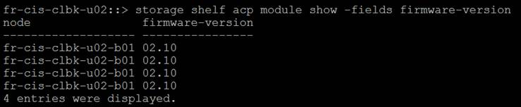

To update the relevant firmware use the following commands:

To download the latest shelf firmware package to all nodes in the cluster from a web server, use this command:

::*>**storage firmware download –node * -package-type all –package http://<**web-server**>/**path**/all_shelf_fw.zip**

To download an individual ACP firmware file to nodes in the cluster from a web server, use this command:

::*>**storage firmware download –node * -package-type acp -package http://<**web-server**>/**path**/<ACPP_type.fw_rev.AFW>.zip**

### ****Reboot Service Processor****

There is a bug that causes the SP to reboot the node if a certain number of days’ uptime is reached. Prior to upgrade reboot the SP as a precautionary measure. **Once rebooted check it is accessible**.

::> system service-processor reboot-sp -node *

Note: If your console connection is through the SP, it will be disconnected.

Do you want to reboot the SP ? {y|n}: y

### ****Generate An Upgrade Advisor****

Upgrade advisors are based off ASUP data so once all issues are resolved with failover groups and interfaces please generate a new ASUP.

**Example**

::> autosupport invoke -node * -type all -message " 9.1P7 UA SnapShot"

Active IQ is used to provide upgrade advisors now. Follow the process below:

Select the version and press Next

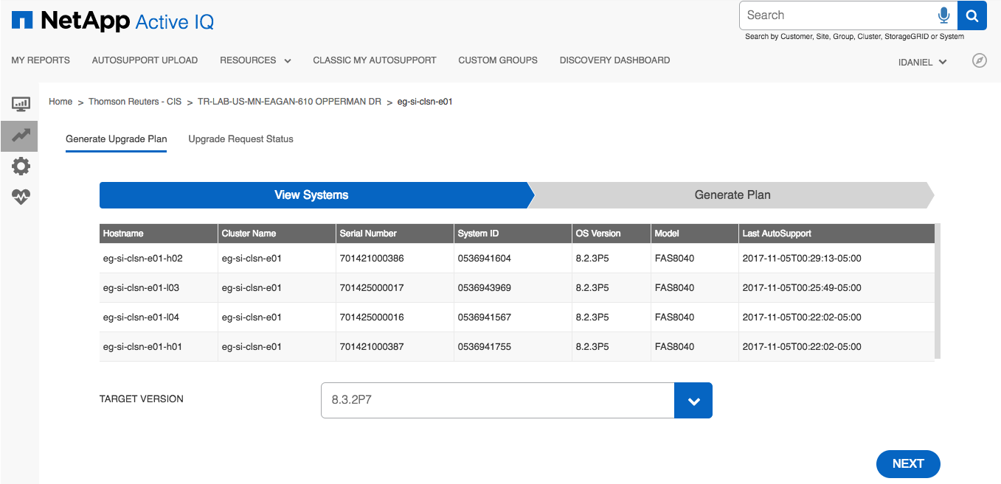

Select the correct options and press Generate

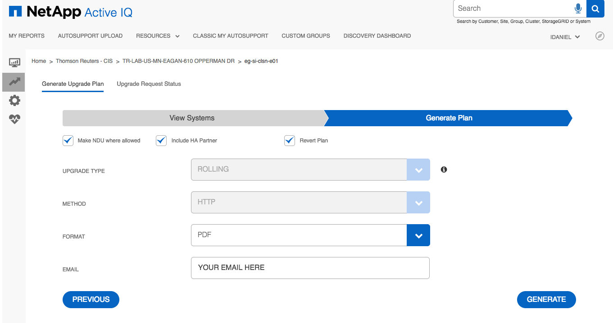

You should see a green status message at the bottom of the window as shown.

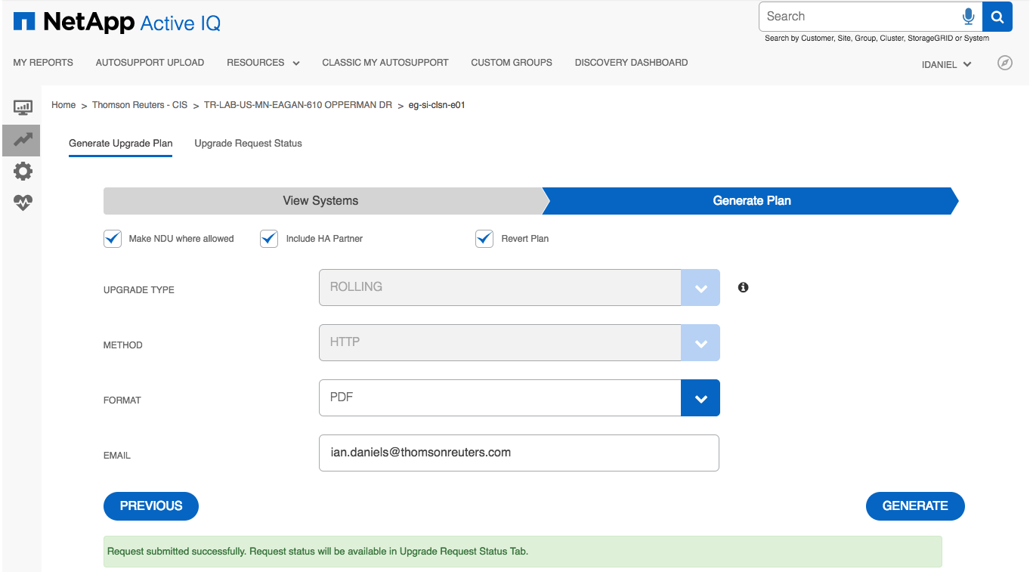

You can see the status by selecting the Upgrade Request Status tab.

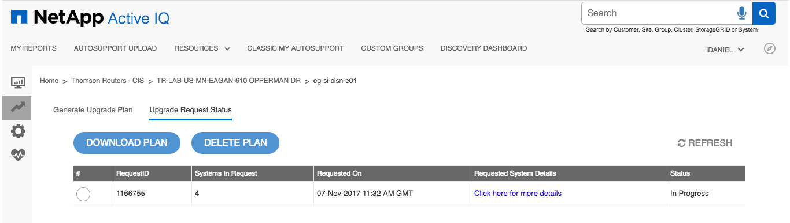

When it’s completed you will receive an email but can also download the plan via the site.

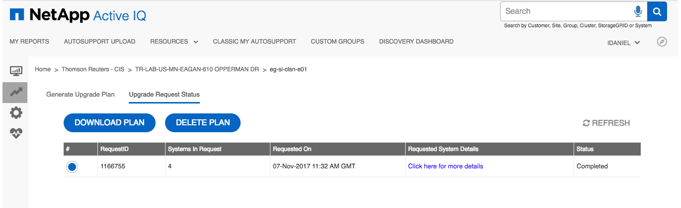

### ****Check Upgrade Advisor****

Read through Upgrade Advisor and check/remediate any issues that are flagged. You can double click the example to open the PDF file.



# Upgrade Process (9.1P12)

## ****Description****

The upgrade process is disruptive on single node controllers.

## ****Tasks****

### Download Code Onto All Nodes

::*> system node image get -node * -package http://10.220.179.83:8080/ONTAP/91P12_q_image.tgz

Software get http://.../91P12_q_image.tgz started on node eg-si-clbk-e02-l01

Downloading package. This may take up to 10 minutes.

99% downloaded

Download complete.

Software get http://.../91P12_q_image.tgz completed on node eg-si-clbk-e02-l01.1 entry was acted on.

eg-si-clbk-e02::*> system node image package show

Package

Node Repository Package File Name

------------ -------------- -----------------

eg-si-clbk-e02-l01

mroot

823P5_q_image.tgz

832P7_q_image.tgz

91P12_q_image.tgz

91P4_q_image.tgz

91P6_q_image.tgz

91P7_q_image.tgz

6 entries were displayed.

### Check All Aggregates Are Online

Any aggregate that is offline needs to be fixed and online prior to upgrade.

::> aggr show -state !online

There are no entries matching your query.

### Check All Aggregates Have Enough Space

Any aggregate using more than 95% space needs to be fixed prior to upgrade

::> aggr show -percent-used >95

There are no entries matching your query.

### Check All Volumes Are Online

All volumes must be online so anything not online needs to be fixed/removed prior to upgrade.

::> vol show -state !online

Vserver Volume Aggregate State Type Size Available Used%

--------- ------------ ------------ ---------- ---- ---------- ---------- -----

or-ss-clbk-e01

cb0001_orprod_svtest_14_snap

aggr1_data_l01

offline DP 1TB - -

or-ss-clbk-e01

cb0001_orprod_svtest_14_snap_clone_1474288594

aggr1_data_l01

offline RW 1TB - -

or-ss-clbk-e01

cb0001_orprod_svtest_14_snap_clone_1474288652

aggr1_data_l01

offline RW 1TB - -

or-ss-clbk-e01

cb0001_orprod_svtest_14_snap_clone_1474288684

aggr1_data_l01

offline RW 1TB - -

or-ss-clbk-e01

cb0001_orprod_svtest_14_snap_clone_1474290232

aggr1_data_l01

offline RW 1TB - -

or-ss-clbk-e01

cb0001_orprod_svtest_14_snap_clone_1474290993

aggr1_data_l01

offline RW 1TB - -

or-ss-clbk-e01

sm_vfiler_to_cdot_svm

aggr1_data_l01

offline DP 6GB - -

or-ss-clbk-e01

sm_vol_7mode_cdot_snapmirror

aggr1_data_l01

offline RW 6GB - -

8 entries were displayed.

### Check All Volumes Have Enough Space

Any volumes using more than 95% space should be adjusted to be below that threshold prior to upgrade.

**The volumes below are an example of this which would require remediation by adding more space prior to upgrading.**

::*> vol show -percent-used > 95

(volume show)

Vserver Volume Aggregate State Type Size Available Used%

--------- ------------ ------------ ---------- ---- ---------- ---------- -----

orprod-iscsi-01

cb0000_wi_15142_05_usr_snap

aggr1_data_h01

online RW 160GB 4.68GB 97%

orprod-iscsi-02

cb0000_wi_or_tsys_nosnap

aggr1_data_h01

online RW 68.26GB 1.99GB 97%

orprod-iscsi-02

cb0000_wi_or_usr_snap

aggr1_data_h01

online RW 634.5GB 993.2MB 99%

orprod-iscsi-03

cb0001_wi_winapp_usr_snap

aggr1_data_h01

online RW 152.6GB 1009MB 99%

orprod-iscsi-04

cb0000_wi_prj11504_usr_snap

aggr1_data_h02

online RW 152.6GB 1009MB 99%

si-8040-test-01

dng_test2 aggr1_data_l03

online RW 1GB 760KB 99%

6 entries were displayed.

### Check For Running Jobs

Check for running volume, aggregate or snapshot jobs.

::*> job show -state running\|queued -name !efficiency-DeDupe

Delete any jobs

::*> job delete -id *JOB_ID*

### Check Number of Snapshots is Less Than 20000 Per Node

set advanced

set -rows 0

volume snapshot show -node *<NODE_NAME>*

**Note:** There’s a count at the end of the output. More than 20000 per node means some will have to be deleted.

### Check For Disks in Maintenance, Pending or Reconstructing State

::*> storage disk show -state maintenance|pending|reconstructing

There are no entries matching your query.

### Quiesce SnapMirror

::*> snapmirror quiesce -destination-path *

### Send ASUPs Prior To Upgrade

::> autosupport invoke -node * -type all -message "pre-upgrade to 9.1P12"

### Disable Case Generation Prior To Upgrade For 4 Hours

autosupport invoke -node * -type all -message "MAINT=4h Starting_UPGRADE"

### Perform Upgrade

eg-si-clbk-e02::*> system node image update -node eg-si-clbk-e02-l01 -package 91P12_q_image.tgz -replace-package true

Software update started on node eg-si-clbk-e02-l01. Updating image2 with package 91P12_q_image.tgz.

Listing package contents.

Decompressing package contents.

Invoking script (install phase). This may take up to 60 minutes.

Mode of operation is UPDATE

Current image is image1

Alternate image is image2

Versions are compatible

Available space on boot device is 6522 MB

Required space on boot device is 958 MB

Kernel binary matches install machine type

NFS netgroup check script is invoked.

netapp_nfs_netgroup_check script begin

NFS netgroup check script has run successfully.

security config check script is invoked.

netapp_security_config_check script begin

security config check script has run successfully.

IPspace limit checker script is invoked.

netapp_ipspace_limit_check script start

netapp_ipspace_limit_check script pass

IPspace limit checker script has validated configuration.

Getting ready to install image

Syncing device...

Extracting to /cfcard/x86_64/freebsd/image2...

x netboot/metadata.xml

x netboot/fw.tgz

x netboot/rootfs.img

x netboot/platfs2g.img

x netboot/BUILD

x netboot/COMPAT.TXT

x netboot/INSTALL

x netboot/VERSION

x netboot/cap.xml

x netboot/kernel

x netboot/netapp_ipspace_limit_check

x netboot/netapp_nfs_netgroup_check

x netboot/netapp_security_config_check

x netboot/platform.ko

x netboot/CHECKSUM

Installed MD5 checksums pass

Installing diagnostic and firmware files

Firmware MD5 checksums pass

Installation complete. image2 updated on node eg-si-clbk-e02-l01.

### Set the image as default image

eg-si-clbk-e02::*> system image show

Is Is Install

Node Image Default Current Version Date

-------- ------- ------- ------- ------------------------- -------------------

eg-si-clbk-e02-l01

image1 true true 9.1P7 9/11/2017 12:17:46

image2 false false 9.1P12 4/10/2018 17:07:28

2 entries were displayed.

eg-si-clbk-e02::*> system image modify {-node eg-si-clbk-e02-l01 -iscurrent false } -isdefault true

After a clean shutdown, image2 will be set as the default boot image on node

eg-si-clbk-e02-l01.

1 entry was modified.

eg-si-clbk-e02::*> system image show

Is Is Install

Node Image Default Current Version Date

-------- ------- ------- ------- ------------------------- -------------------

eg-si-clbk-e02-l01

image1 false true 9.1P7 9/11/2017 12:17:46

image2 true false 9.1P12 4/10/2018 17:07:28

2 entries were displayed.

### Reboot the single node backup cluster

system node reboot -node eg-si-clbk-e02-l01 -reason "software upgrade 9.1P12"

Login to SP and check the reboot process. Once filer reboots check the version.

# Post-Upgrade Process (9.1P12)

## Description

After the upgrade is completed and the node is on ONTAP 9.1P12 we need to resume SnapMirror. Wait for 1 minute after the system has booted before running this command to ensure SnapMirror processes are running.

### Resume SnapMirror

::> snapmirror resume -destination-path *